PRICE LIST - FROZEN CHICKEN

IMAGE | DESCRIPTION | PACKAGING | WEIGHT | AVAILABILITY | PRICE | UNIT
 |  |  |  |  |  | EUR/ KG
CHICKEN
 | chicken breast single with inner | Naked block | 15 Kg |  | 4,25 € | EUR/ KG
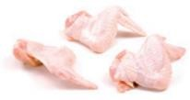 | chicken wings | White Carton | 10 Kg |  | 2,26 € | EUR/ KG
HEAVY HEN
 | heavy hen breast A grade | Block | 15 Kg | January 2025 | 4,13 € | EUR/ KG
 | heavy hen feet AB grade | White Carton or Polyblock | 10 Kg | January 2025 | 2,10 € | EUR/ KG
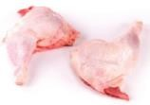 | heavy hen leg quarters B grade | White Carton | 10 Kg | January 2025 | 1,56 € | EUR/ KG
 | heavy hen leg quarters cut | Lech Drob carton | 10 Kg | January 2025 | 2,05 € | EUR/ KG
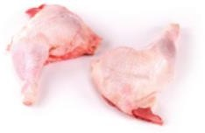 | heavy hen leg quarters | Lech Drob carton | 10 Kg | January 2025 | 1,95 € | EUR/ KG
 | heavy hen wings | Lech Drob carton | 10 Kg | January 2025 | 1,95 € | EUR/ KG
 | heavy hen wings B grade | White Carton | 10 Kg | January 2025 | 1,37 € | EUR/ KG
ROOSTER
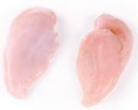 | heavy rooster breast | A grade block | 15 Kg | End December 2024/January 2025 | 3,95 € | EUR/ KG
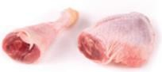 | rooster leg quarters | White Carton | 10 Kg | January 2025 | 1,56 € | EUR/ KG
HEN
 | hen minced meat 3mm | Naked Polyblock | 15 Kg | October 2024 | 3,80 € | EUR/ KG

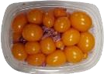 | hen OVARIES 500G | Carton | 0,500 Kg |  | 4,21 € | 500 GR/ CARTON
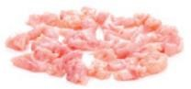 | hen red trimming | Polyblock | 15 Kg |  | 2,69 € | EUR/ KG
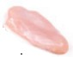 | light hen breast single with inner | Naked block | 15 Kg | End December 2024/January 2025 | 4,15 € | EUR/ KG
 | light hen feet AB grade | White Carton or Polyblock | 10 Kg | January 2025 | 0,98 € | EUR/ KG
 | light hen leg quarters | Lech Drob carton |  | January 2025 | 2,16 € | EUR/ KG
 | light hen leg quarters B grade | White Carton | 10 Kg | January 2025 | 1,56 € | EUR/ KG
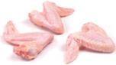 | light hen wings | Lech Drob carton | 10 Kg | January 2025 | 1,97 € | EUR/ KG
 | light hen whole 8-11 pcs | Carton | 10 Kg | January 2025 | 2,16 € | EUR/ KG
 | light hen HALAL | IWP | 800-1100 GR | January 2025 | 2,11 € | EUR/ KG
FRANKS & MORTADELLA
 | chicken Franks CHEESE 340gx 30pcs „Premium Chicken”  brand | Carton |  | End December 2024 | 2,11 € | EUR/ KG
 | chicken Franks CREOLE 340gx 30pcs „Premium Chicken”  brand | Carton |  | End December 2024 | 2,11 € | EUR/ KG
 | chicken Franks NATURAL 340g x 30pcs „Premium Chicken”  brand | Carton |  | End December 2024 | 1,98 € | EUR/ KG
 | chicken Franks SPICY 340gx30pcs „Premium Chicken”  brand | Carton |  | End December 2024 | 2,01 € | EUR/ KG
 | chicken Mortadella 1000g „Premium Chicken” brand | Carton | 12 Kg | End November 2024 | 1,53 € | EUR/ KG

 | chicken Mortadella 500g „Premium Chicken” brand | Carton | 12 Kg | End November 2024 | 1,54 € | EUR/ KG
 | chicken Mortadella Paprica 500g „Premium Chicken”  brand | Carton | 12 Kg | End November 2024 | 1,70 € | EUR/ KG

